NON RETURNABLE DELIVERY CHALLAN
WATER WORKS ENGINEERING
#65-B, GURUSAMY NAGAR, THANNEERPANDAL, PEELAMEDU,
COIMBATORE-641 004
TELE NO.: 0422 2511139  CELL : 98650 13676/ 99427 44822  E mail :waterworksengineeringcbe@gmail.com |  | D.C No. :  DATE :
CONSIGNER' S NAME & ADDRESS:  WATER WORKS ENGINEERING  #65-B, GURUSAMY NAGAR, THANNEERPANDAL, PEELAMEDU,  COIMBATORE-641 004. |  | DELIVER TO:
 | DESCRIPTION | QTY
(NOT FOR SALE , OWN USE ONLY)
PARTY GST NO.:

Received the above on goods condition  Signature of the party |  | For WATER WORKS ENGINEERING  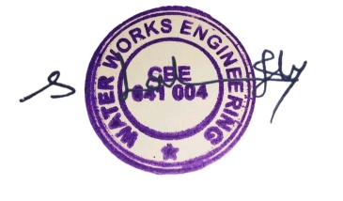  AUTHORIZED SIGNATORY

